PROJECT REPORT

KINDERGARTEN MANAGEMENT SYSTEM

|  |  |
| --- | --- |
| MEMBERS | REGISTRATION NUMBER |
| ILLYA NATASYA BINTI HUZAIR | 18DDT18F1010 |
| NUR ADIELA BINTI MOHD GHAUS | 18DDT18F1014 |
| FATIN NUR IZZATI BINTI MOHARIZAL | 18DDT18F1058 |

DEPARMENT OF INFORMATION & COMMUNICATION TECHNOLOGY

POLITEKNIK TUANKU SYED SIRAJUDDIN, PERLIS

SESSION JUNE 2020

**Table of Contents**

**Pages**

1. **PROJECT PLAN**
   1. Introduction ……………………………………………………………………………..2
   2. Problem Statement ……………………………………………………………………..2-3
   3. Objectives of Project ……………………………………………………………………3
   4. Scope of Project ………………………………………………………………………..3-4
   5. Literature Review …………………………………………………………………….....4
   6. Methodology of Project …………………………………………………………………5
   7. Project Gantt Chart ……………………………………………………………………...6
2. **REQUIREMENT SPECIFICATION**
   1. Functional Requirement …………………………………………………………………7
   2. Non Functional Requirement ………………………………………………………......7-8
   3. Hardware and Software Requirement ………………………………………………….8-9
   4. System Configuration ……………………………………………………………………9
   5. Security Requirement / Exceptional Handling ……………………………………….....10
3. **FINAL DESIGN**
   1. Logical Design ………………………………………………………………………..11-13
   2. Physical Design ……………………………………………………………………....14-20
4. **TEST DESCRIPTION AND RESULTS**
   1. Unit Testing Plan ………………………………………………………………………..22
   2. Integration Testing Plan …………………………………………………………………23
5. **DISCUSSIONS**
   1. Advantage of the Project ………………………………………………………………...24
   2. Limitation of the Project …………………………………………………………………24
6. **CONCLUSIONS** ..............................................................................................................24
7. **REFERENCE** …………………………………………………………………………...25

**List of Tables**

**Pages**

1. **PROJECT PLAN**

Table 1.1 …………………………………………………………………………….4

Table 1.2 ….................................................................................................................5

Table 1.3 …………………………………………………………………………….6

1. **REQUIREMENT SPECIFICATION**

Table 2.1 …………………………………………………………………………….8

Table 2.2 …………………………………………………………………………….9

1. **TEST DESCRIPTION AND RESULTS**

Table 4.1 ………………………………………………………………………........22

Table 4.2 ……………………………………………………………………………23

**List of Figures**

**Pages**

1. **PROJECT PLAN**

Figure 1.1 ……………………………………………………………………………4

Figure 1.2 …................................................................................................................4

Figure 1.3 ….................................................................................................................5

1. **FINAL DESIGN**

Figure 3.1 …………………………………………………………………………….14

Figure 3.2 …................................................................................................................14

Figure 3.3 …................................................................................................................15

Figure 3.4 ……………………………………………………………………………15

Figure 3.5 …................................................................................................................16

Figure 3.6 …................................................................................................................16

Figure 3.7 ……………………………………………………………………………17

Figure 3.8 …................................................................................................................17

Figure 3.9 …................................................................................................................18

Figure 3.10 …………………………………………………………………………..18

Figure 3.11 …..............................................................................................................19

Figure 3.12 …………………………………………………………………………..19

Figure 3.13 …..............................................................................................................20

Figure 3.14 …..............................................................................................................20

Figure 3.15 …..............................................................................................................21

Figure 3.16 …..............................................................................................................21

1. **PROJECT PLAN**
   1. **Introduction**

A kindergarten is important places to produce a good student, who will be become quality citizen for the country. Therefore, managing kindergarten effectively and efficiency needs more attention. Good kindergarten are kindergarten that have good management system. With the system, the performance of kindergarten will be improved. For example in the management of student’s attendance that kindergarten should be managed consistently. This allows all the events or attendance are kept well and safe and can be reviewed when necessary.

Technology is everyday these days, but kindergarten still take the attendance manually. The main purpose of this system is to make things easier for teachers. The system that we want to develop will make teachers burden off by not taking student's attendance in a book anymore. All attendance will be recorded automatically in the system by student just have to tap the tag on the RFID reader.

Next, as we all know that when parents had done with their child’s school fee, they have to contact the teacher personally. With this system, apps will be developed for parents to upload their receipt of successful payment there and teachers can check and then approved the receipt.

Our client, Tabika Kemas Taman Cheras Jaya are stated in Balakong, Selangor. This system will helps the kindergarten’s teacher to manage all the student’s attendance wisely and kept the attendance record safe and can be reviewed when necessary.

* 1. **Problem Statement**

The attendance management previously done manually. But today, people more concerned about speed and speed in dealing with something and want it done in consistent and simple. With development of software, it can help solve problems.

For kindergarten attendance management, the most common problem that always happen is the attendance record are keep missing. This is because any information store in place like rack should not be possible to loss. Method of using paper or manual way also invited to loss information. It is also occur damage to the paper. Extensive use of paper cause lost and waste time.

The other problem is time consuming that kindergarten’s teacher used when manually filled the attendance and to called out the students one by one. Next, when the teachers need to find the student’s attendance record, they need a long time to find the old record. So this will make teacher’s work become harder.

Last but not least, as we all know, when parents want to inform that they have done their payment, they need to contact the teacher personally because there is no apps that can help solved it. So this will make the teacher’s had no privacy.

* 1. **Objectives of Project**

The objectives of the project are :

1. To develop a web based system for kindergarten attendance management by tap the tag at the RFID reader.
2. To make a web based system for parents as reminder to check whether they had done their payment or not.
3. To manage monthly attendance record list and check school’s fee.
   1. **Scope of Project**
      1. **User Scope**
4. Teachers :

Users who will maintain the system by managing student’s attendance and student’s information.

1. Students :

User who are register under the system and have their personal tag to scan to the RFID reader attendance.

1. Parents :

Users who can check whether they are done with payment the school’s fee.

* + 1. **System Scope**

1. Register student :

Register the user of the system. Teachers will be registered student’s list.

1. Manage student :

Teachers will get to manage student’s list like teachers can edit, add and remove students they want to. Then, they can check and approved receipt that parents upload on the apps.

1. Manage School’s Fee :

Parents can check whether they are done with payment the school’s fee.

* + 1. **Location Scope**

Tabika Kemas Taman Cheras Jaya is located at Balakong, Selangor. The full address of the company is No 25 (Madrasah An-Nuriah) Jalan 12/4 43200 Balakong, Selangor Darul Ehsan

Figure 1.2 shows the maps of Tabika Kemas Taman Cheras Jaya on the Maps. Tabika Kemas Taman Cheras Jaya is located near the Madrasah An-Nuriah.

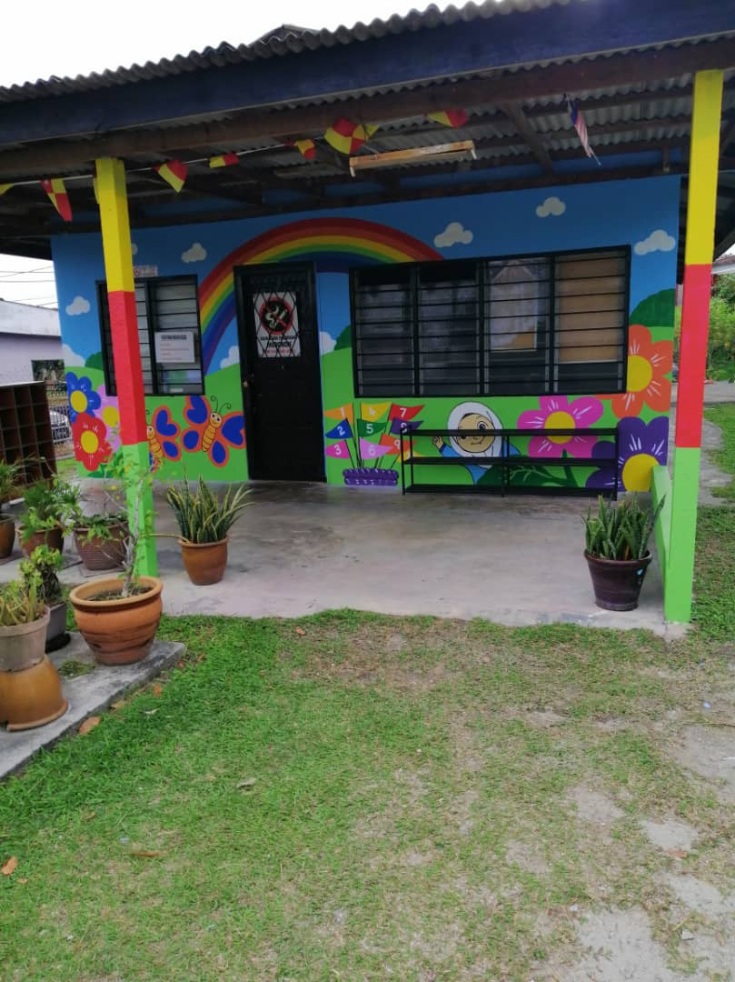

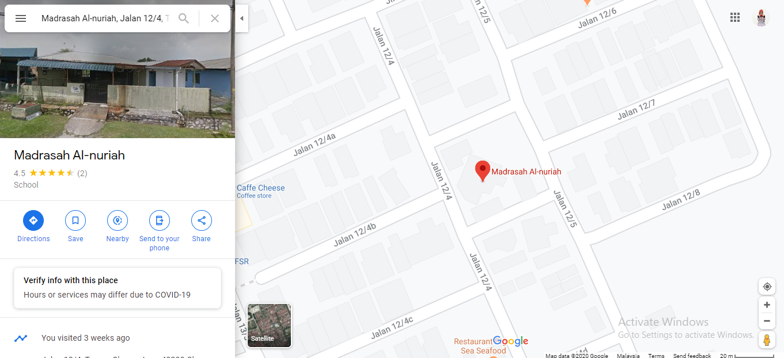

Figure 1.2 Location Tabika Kemas Taman Cheras Jaya

Figure 1.1 Tabika Kemas Taman Cheras Jaya

* 1. **Literature Review**

|  |  |  |  |  |
| --- | --- | --- | --- | --- |
| **System name**  **Function** | **SPMP** | **Microsoft Teams** | **SARKES** | **PROJECT** |
| Have attendance list | X | **/** | X | **/** |
| Can check Result Exam | **/** | X | X | X |
| Can edit student’s Information | X | X | X | **/** |
| Have temperature information | X | X | **/** | X |
| Can add new students | **/** | **/** | **/** | **/** |

Table 1.1 Literature Review

* 1. **Methodology of Project**

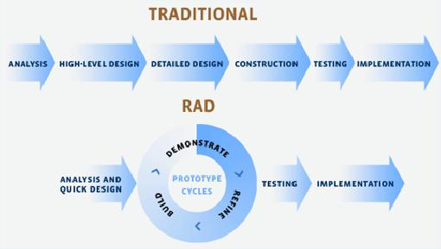

Figure 1.3

Table 1.2 Methodology

|  |  |
| --- | --- |
| **PHASE** | **EXPLANATION** |
| 1) Analysis and quick design | Identify the usefulness of the Kindergarten RFID Attendance System |
| 2) Build | Build a Kindergarten RFID Attendance System |
| 3) Demonstrate | Show the built-in output. |
| 4) Refine | Find the corruption by built-in output.,if there is no system error to the next step,if there has a error this step cycle will repeat till no error. |
| 5) Testing | We will first tested the system before giving the client to try using the system to see if it worked. |
| 6) Implementation | We approved the system for the client to use this Kindergarten RFID Attendance System |

* 1. **Project Gantt Chart**

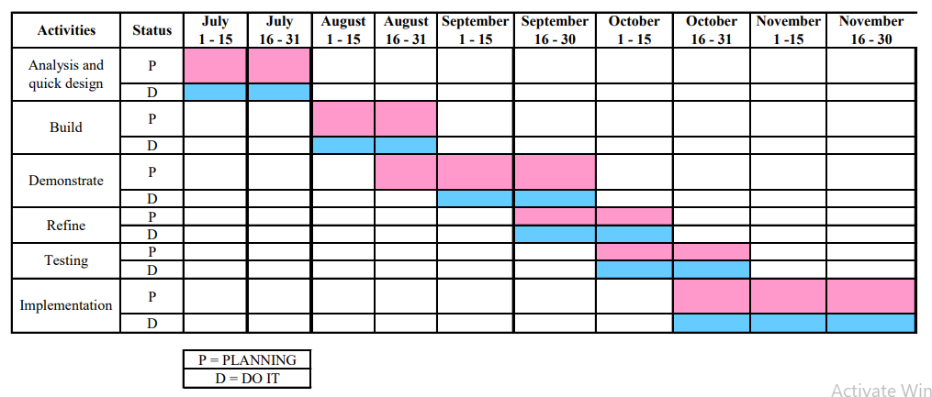Table 1.3 Gantt Chart

1. **REQUIREMENT SPECIFICATION**

**2.1 Functional Requirement**

A Functional Requirement (FR) is a description of the service that the software must offer. It describes a software system or its component. A function is nothing but inputs to the software system, its behaviour, and outputs. It can be a calculation, data manipulation, business process, user interaction, or any other specific functionality which defines what function a system is likely to perform.

* Log into the system.
* Admin register students.
* Admin register parents.
* Admin update and delete information students.
* Admin update and delete information parents.
* Admin update and delete information payment fee of students
* Parents can view payment fee of students.
* Admin must confirm the attendance for students to acces RFID.
* Admin must confirm the attendance for students.
* Finally,logout.

**2.2 Non Functional Requirement**

In systems engineering and requirements engineering, a non-functional requirement (NFR) is a requirement (NFR) is a requirement that specifies criteria that can be used to judge the operation of a system, rather than specific behaviors. They are contrasted with functional requirement that define specific behaviour or functions. The plan for implementing functional requirements is detailed in the system design. The plan for implementing non-functional requirements is detailed in the system design. The plan for implementing non-functional requirements is detailed in the system architecture because they are usually architecturally significant requirements.

2.2.1 Security

* The system have accounts for its user and parents
* User and parents can access the system with username and password.

2.2.2 Performance

* Easy tracking of records and updating can be done.

2.2.3 Availability

* The system are available to users anytime, anywhere, just need a Internet Connection.

7

* The system work in multiple web browsers like (Chrome, Mozilla, and Internet Explorer.

2.2.4 Usability

* The system must be quickly accessed by teachers and parents.
* The system must be intuitive and simple in a relevant data and relationships.
* The system menu must be easily navigated by the user with a button which is easy to understand.
  1. **Hardware and Software Requirement**
     1. HARDWARE

The most common set of requirements defined by any operating system or software application is the physical computer resources, also known as hardware, A hardware requirements list is often accompanied by a hardware compatibility list (HCL), especially in case of operating system. An HCL lists tested, compatible, and sometimes incompatible hardware devices for a particular operating system or application. The following sub-sections discuss the various aspects of hardware requirements.

|  |  |
| --- | --- |
| **HARDWARE** | **EXPLANATION** |
| Arduino Nodemcu Esp8266 | Use to connect the system directly to WIFI |
| Rfid-Rc522 Module | Use to scan tag of attendance student |
| Jumper Wire | Use to connect NodeMCU to RFID-RC522 Module |
| Micro Usb Cable | Use to connect the monitor with Arduino NodeMCU |
| Monitor | Use to configure the coding in the Arduino NodeMCU |
| Laptop / PC | Use to develop system |
| Keyboard | Use to insert input to the monitor interface |
| Mouse | Use to select an items in the monitor interface |

Table 2.1 Hardware

* + 1. SOFTWARE

A software requirements specification (SRS) is a description of a software system to be developed. It is modeled after business requirements specification (CONOPS), also known as a stakeholder requirements specification (StRS). The software requirements specification lays out functional and non-function requirements, and it may include a set of use cases that describe user interactions that the software must provide to the user for perfect interaction.

Table 2.2 Software

|  |  |
| --- | --- |
| **SOFTWARE** | **EXPLANATION** |
| Xampp | Use to create database for the system |
| Php | Use to executed on the server and the plain HTML result is sent to browser |
| Notepad++ | Use to write a coding HTML |
| Mysql | Use to create database for the system |
| Microsoft Word | Use to make proposal and report |
| Microsoft Excel | Use to make gantt chart |
| Arduino IDE | Use to connect with hardware |

* 1. **System Configuration**

A system configuration (SC) in systems engineering defines the computers, processes, and devices that compose the system and its boundary. More generally, the system configuration is the specific definition of the elements that define and/or prescribe what a system is composed of :

1. User login to the system as admin or parents by inserting username and password then press the login button.
2. If user forget their password,click button forgot your password link.
3. If login successful, admin need to register parents details.
4. The information message will appear to let user know the data has been saved.
5. To update ,delete , and confirm just click the button.
6. Admin can view students detail and parents detail.
   1. **Security Requirement / Exceptional Handling**

In computing and computer programming, exception handling is the process of responding to the occurrence of exceptions – anomalous or exceptional conditions requiring special processing - during the execution of a program. In general, an exception breaks the normal flow of execution and executes a pre-registered exception handler; the details of how this is done depend on whether it is a hardware or software exception and how the software exception is implemented. It is provided by specialized programming language constructs, hardware mechanisms like interrupts, or operating system (OS) inter-process communication (IPC) facilities like signals. Some exceptions, especially hardware ones, may be handled so gracefully that execution can resume where it was interrupted.

LOG IN

* Kindergarten Management System provide user authorization for login
* Kindergarten Management System provide alert message for wrong input username and password.

1. **FINAL DESIGN**
   1. **Logical Design**
2. Flow Chart

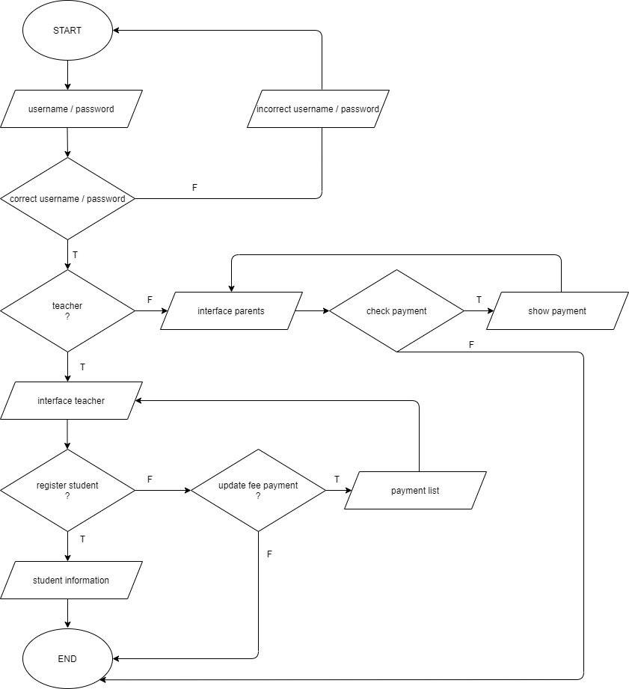

1. Data Flow Diagram

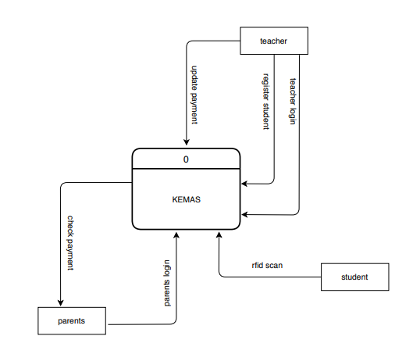

1. Crow Foot

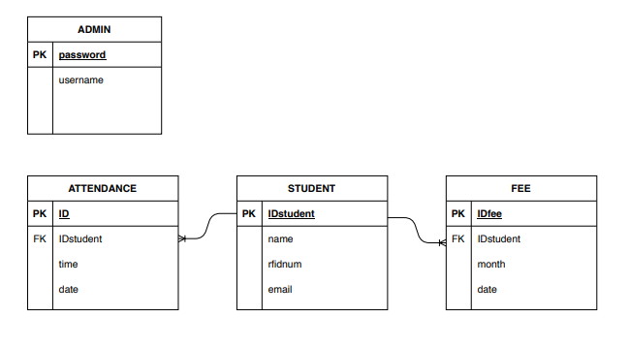

1. Context Diagram

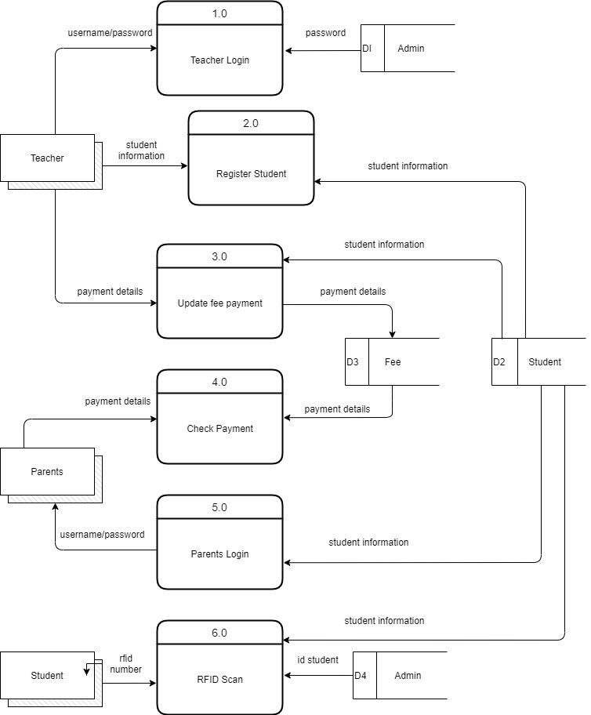

**3.2 Physical Design**

1) Interface for Admin

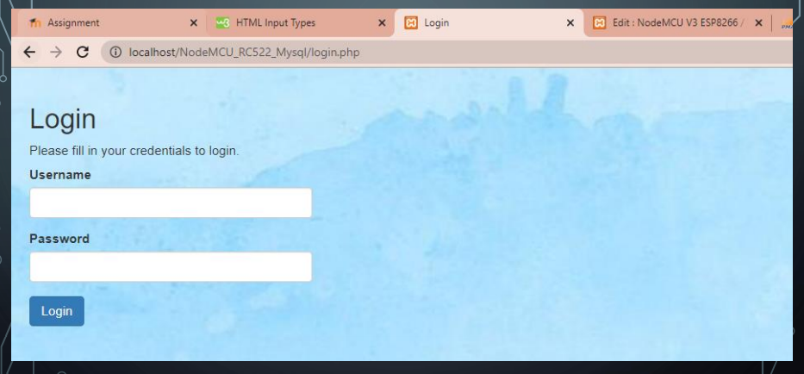

Figure 3.1 Interface for Admin

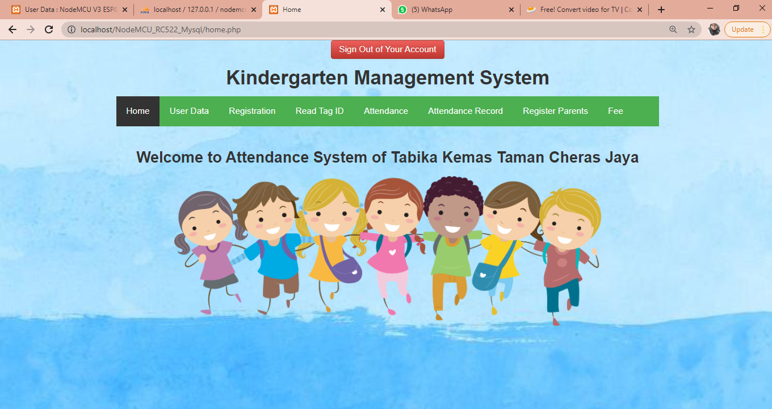

Figure 3.2 Interface for Admin

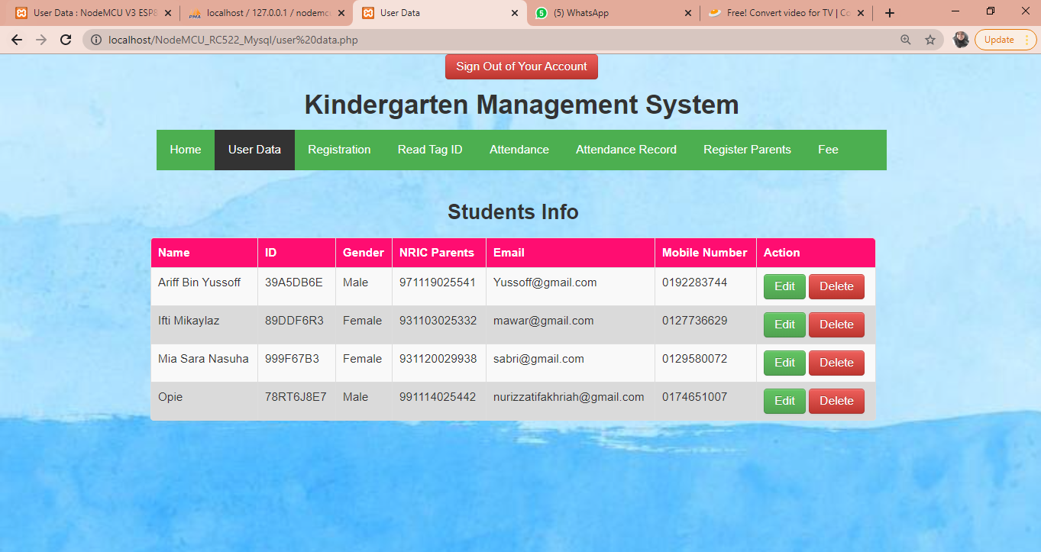

Figure 3.3 Interface for Admin

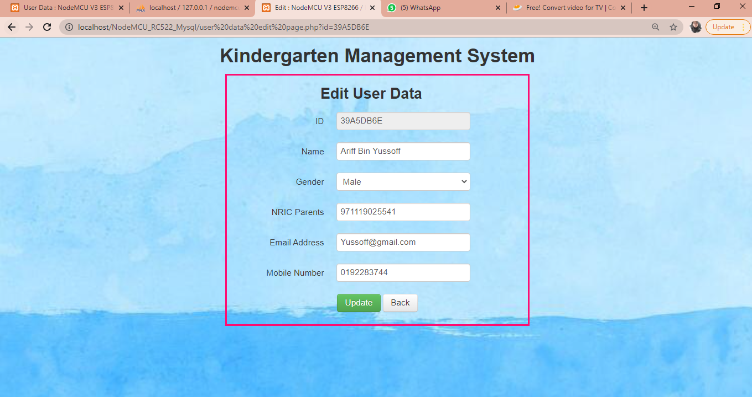

Figure 3.4 Interface for Admin

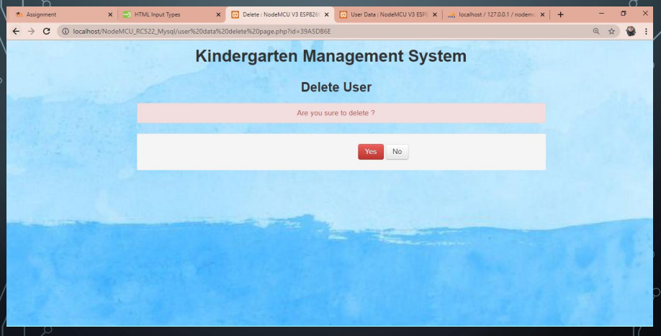

Figure 3.5 Interface for Admin

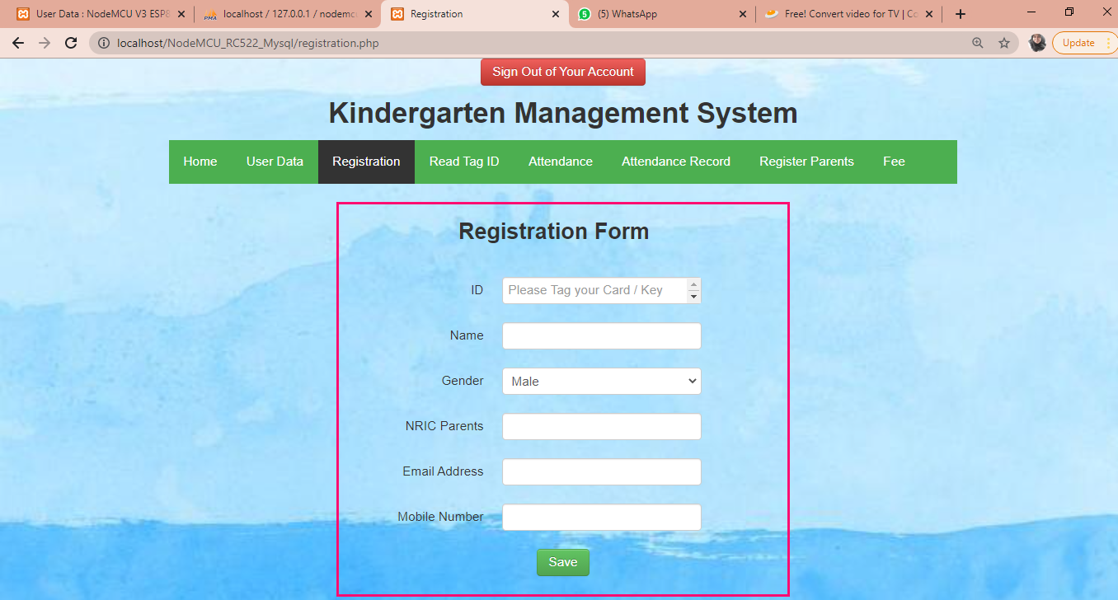

Figure 3.6 Interface for Admin

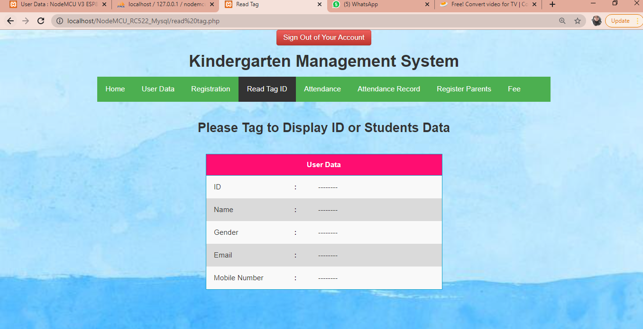

Figure 3.7 Interface for Admin

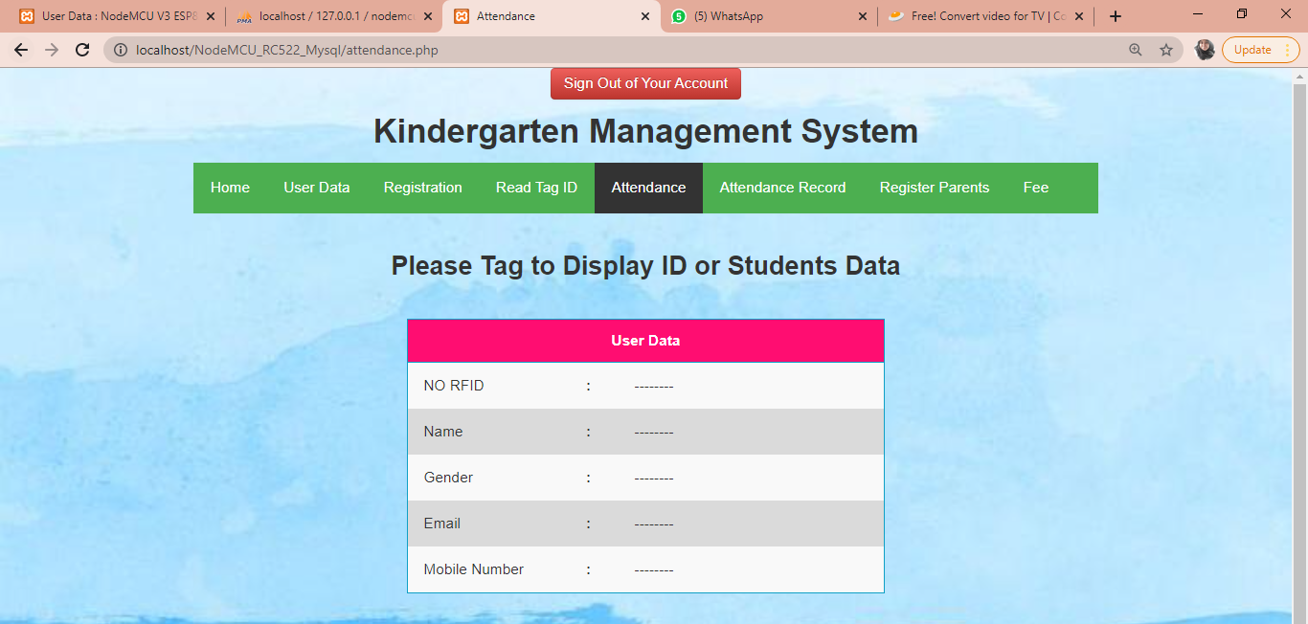

Figure 3.8 Interface for Admin

Figure 3.9 Interface for Admin

Figure 3.10 Interface for Admin

Figure 3.11 Interface for Admin

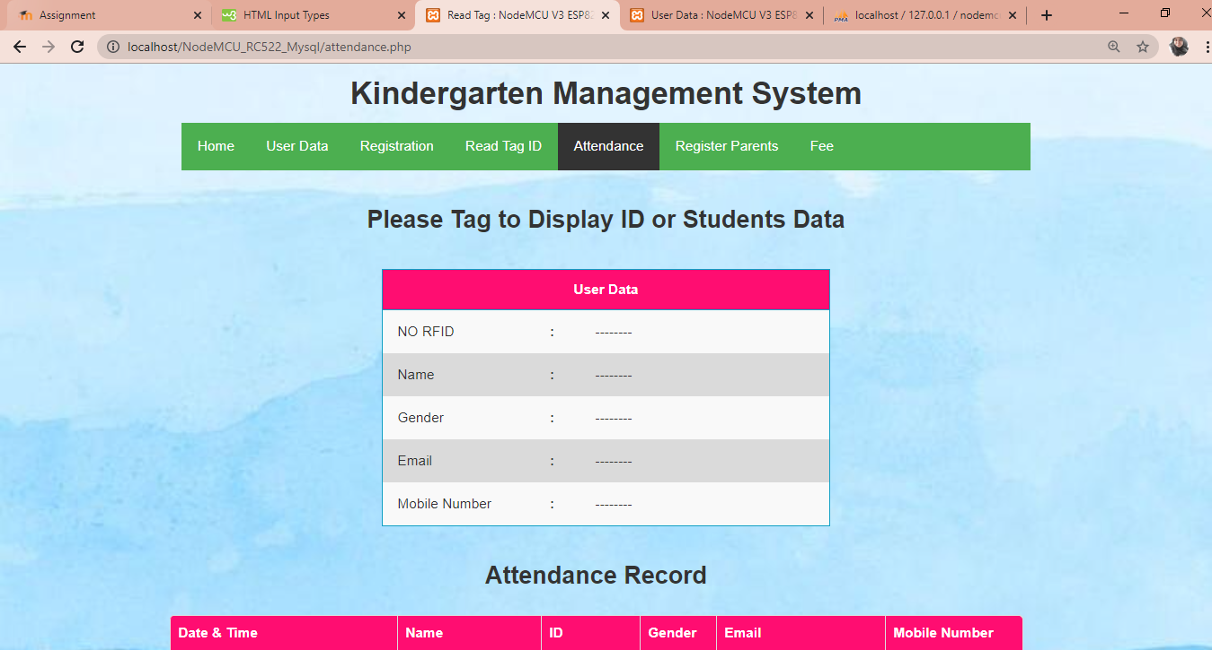



Figure 3.8 Interface for Admin

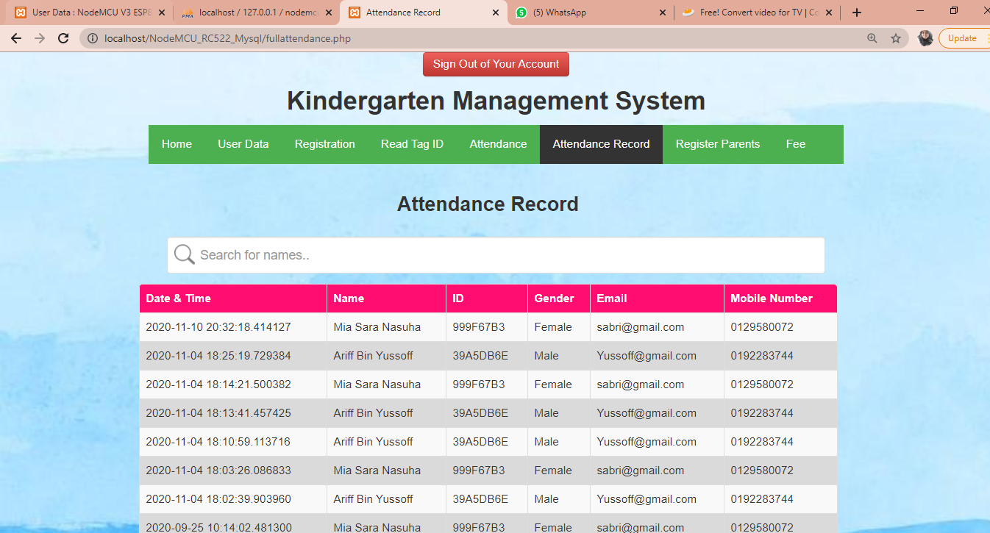

Figure 3.9 Interface for Admin

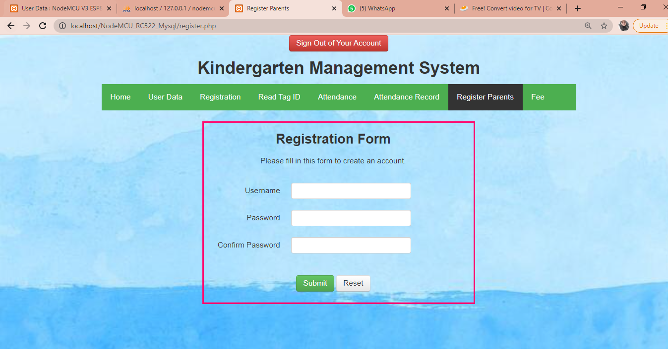

Figure 3.10 Interface for Admin

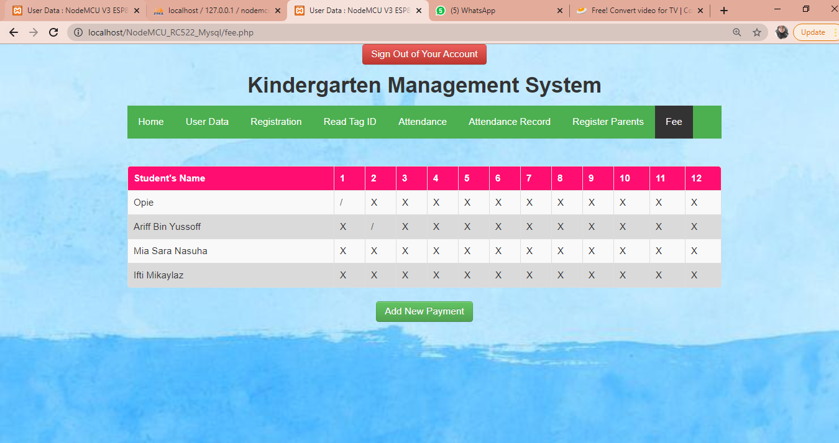

Figure 3.11 Interface for Admin

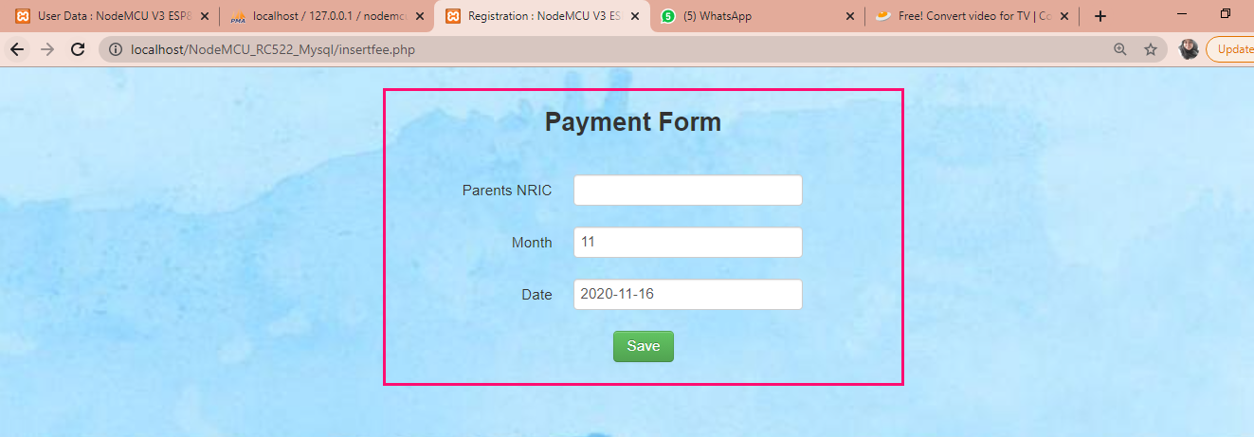

Figure 3.12 Interface for Admin

2) Interface for Parents

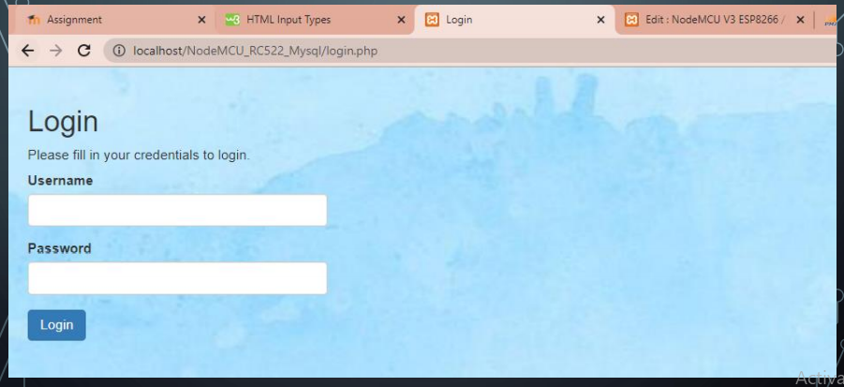

Figure 3.13 Interface for Parents

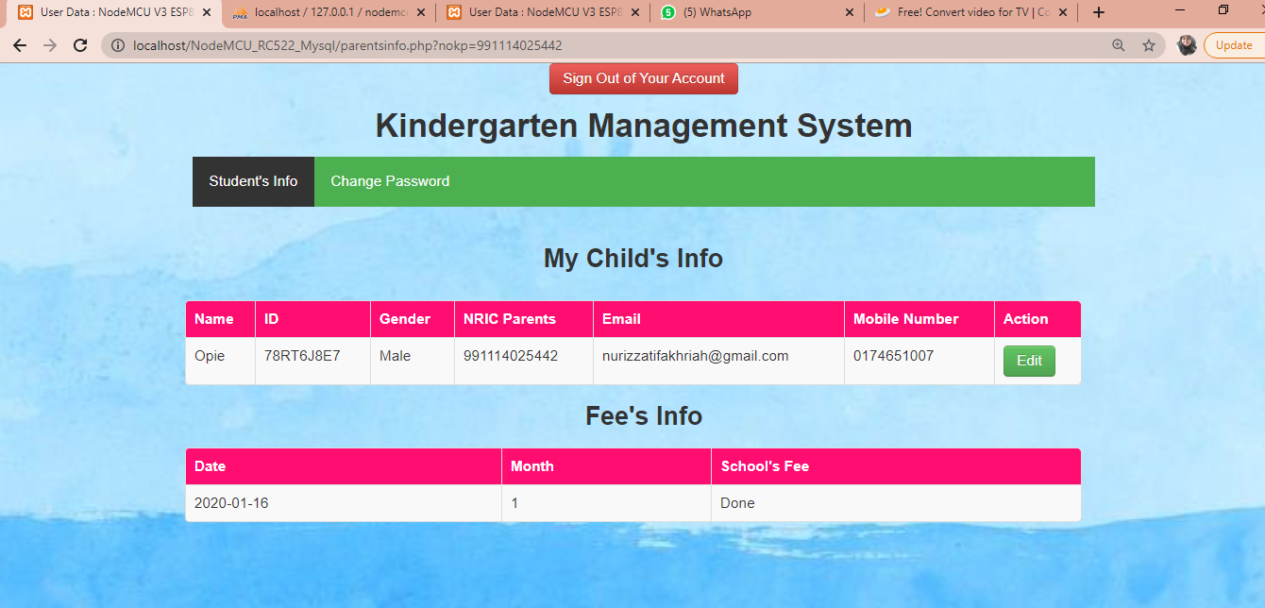

Figure 3.14 Interface for Parents

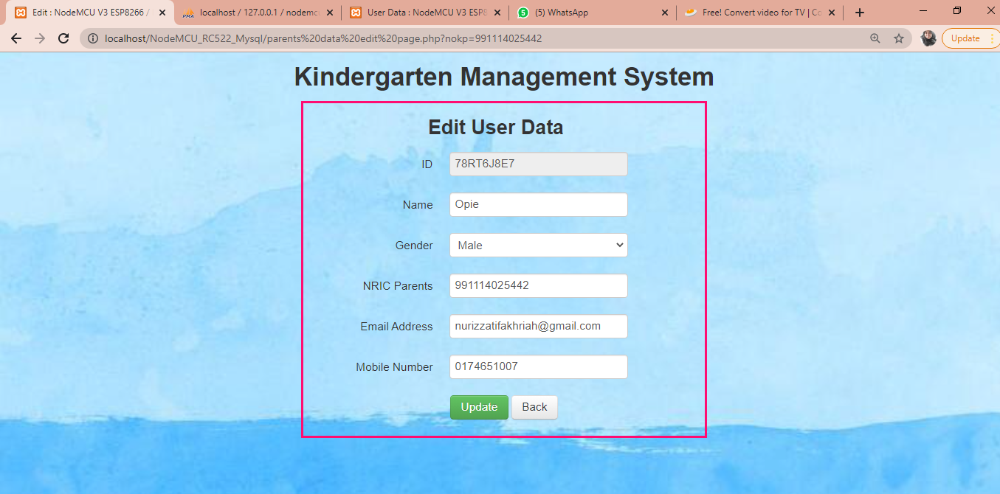

Figure 3.15 Interface for Parents

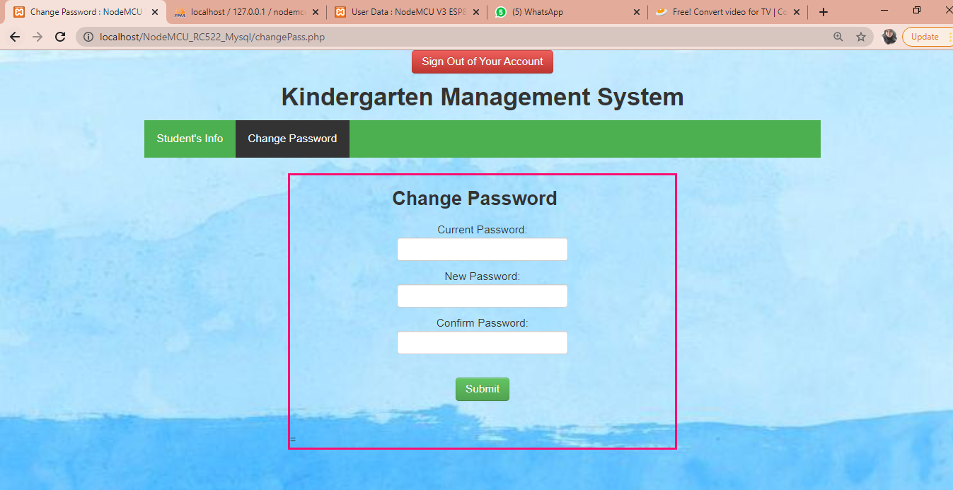

Figure 3.16 Interface for Parents

1. **TEST DESCRIPTION AND RESULTS**

**4.1 Unit Testing Plan**

|  |  |  |  |  |  |  |
| --- | --- | --- | --- | --- | --- | --- |
| UNIT TESTING PLAN (UTP) | | | | | | |
| No | Test Case  Name | Test  Procedure | Pre-  Condition | Expected  Result | Tester | Result  (Pass/Failure) |
| 1. | Login | User is required to fill the username and password. | Username and password are already set in system without registration. | User will directly go to homepage after login. | Diela | Pass |
| 2. | Logout | User logout from the system by click logout button. | None | User will directly go to login page after clicking button logout. | Fatin | Pass |
| 3. | Update | Admin can update data parents and student. | Parents details and students details are already set in system. Click button Update to change data. | Notifications will review pop up and the data will change automatically in user page. | Tasya | Pass |
| 4. | Delete | Admin can delete data parents and student. | Parents details and students details are already set in system. Click button Update to change data. | Notifications will review pop up and the data will delete automatically in user page. | Tasya | Pass |

Table 4.1.Unit Testing Plan (UTP)

**4.2 Integration Testing Plan**

|  |  |  |  |  |  |  |
| --- | --- | --- | --- | --- | --- | --- |
| INTEGRATION TESTING PLAN (ITP) | | | | | | |
| No | Test Case  Name | Test  Procedure | Pre-  Condition | Expected  Result | Tester | Result  (Pass/Failure) |
| 1. | Login | User is required to fill the username and password. Also, click  Button after fill username and password to access the system. | Username and password are already set in system without registration. | User will directly go to homepage after login. | Diela | Pass |
| 2. | Logout | User logout from the system by click logout button. | None | User will directly go to login page after clicking button logout. | Fatin | Pass |
| 3. | Update | Admin can update data parents and student. Click Button update. | Parents details and students details are already set in system. Click button Update to change data. | Notifications will review pop up and the data will change automatically in user page. | Tasya | Pass |
| 4. | Delete | Admin can delete data parents and student. Click Button delete. | Parents details and students details are already set in system. Click button Update to change data. | Notifications will review pop up and the data will delete automatically in user page. | Tasya | Pass |

Table 4.2 Integration Testing Plan (ITP)

**5.0 DISCUSSIONS**

**5.1 Advantages of the Project**

The advantages of the project are :

1. To make things easier for teachers because teachers does not need to jot it down the attendance on the paper anymore.
2. To saves a lot time because does need to jot down the student’s attendance in a book manually hence use the system
3. To make things more easier for parents because parents can check

school’s fee in website.

**5.2 Limitation of the Project**

The system only covers the monitoring of attendance of the students and parents check whether they have paid their children’s school fee. This system is not monitoring the class schedule and the faculties of the school .

**6.0 CONCLUSIONS**

Kindergarten Attendance Record System are develop to overcome the current problem which is to help to manage the student’s attendance wisely. Next, this system also helps lighten teacher’s burden because teachers can manage the student’s information only by the system and does not need to jot it down on the paper like it used to be anymore. This bring a lot of benefits to the teacher hence the students. It is because as we all know, this system can saves a lot of time. This is because of the time that kindergarten’s teacher used when manually filled the attendance. It is such a waste.

This project will beneficial both parents and teachers. This is because parents can check whether they have paid their children’s school fee. This bring much easier to the both teacher and parents.

This Kindergarten RFID Attendance System are proven can help to manage the attendance record efficiently. This project will be beneficial for the kindergarten because the attendance management system will be upgrade from manual written to only check in the system.

**7.0 REFERENCE**

**Website**

<https://www.theengineeringprojects.com/2018/06/introduction-to-arduino-uno.html>

<https://learn.sparkfun.com/tutorials/how-to-use-a-breadboard/all>

<http://www.ia.omron.com/support/guide/47/introduction.html#:~:text=RFID%20System%20is%20an%20abbreviation,or%20Reader%2FWriters)%22.>

<https://www.instructables.com/id/How-to-Interface-RFID-to-Arduino/>

<https://diyi0t.com/rfid-sensor-tutorial-for-arduino-and-esp8266/>

<https://create.arduino.cc/projecthub/embedotronics-technologies/arduino-sending-sensor-data-to-mysql-server-phpmyadmin-a604d4>

**Ebook**

Agrawal A, Bansal A. Online attendance management system using RFID with object counter. International Journal of Information and Computation Technology. 2013 May;3(3):131-8.

Mishra, Yashi, Gaganpreet Kaur Marwah, and Shekhar Verma. "Arduino Based Smart RFID Security and Attendance System with Audio Acknowledgement." *International Journal of Engineering Research and Technology* 4, no. 1 (2015): 363-367.

Ansari, Aamir Nizam, Arundhati Navada, Sanchit Agarwal, Siddharth Patil, and Balwant A. Sonkamble. "Automation of attendance system using RFID, biometrics, GSM Modem with. Net framework." In *2011 International Conference on Multimedia Technology*, pp. 2976-2979. IEEE, 2011.

Kassim, Murizah, et al. "Web-based student attendance system using RFID technology." *2012 IEEE Control and System Graduate Research Colloquium*. IEEE, 2012.

Kassim, M., Mazlan, H., Zaini, N., & Salleh, M. K. (2012, July). Web-based student attendance system using RFID technology. In *2012 IEEE Control and System Graduate Research Colloquium* (pp. 213-218). IEEE.

Kassim, Murizah, Hasbullah Mazlan, Norliza Zaini, and Muhammad Khidhir Salleh. "Web-based student attendance system using RFID technology." In *2012 IEEE Control and System Graduate Research Colloquium*, pp. 213-218. IEEE, 2012.